Annex T: Forest cover and potential forestry interventions in the Project Landscape

I. FOREST COVER AND MANAGEMENT
The “Managing Together” project landscape harbours at least 7,829 ha of plantation forests in six blocks, while all of them are comprised of Teak (Please see figure 1 for their location within the project landscape and Table 1 for their extents – numbers given in the figure refer to those in the table)

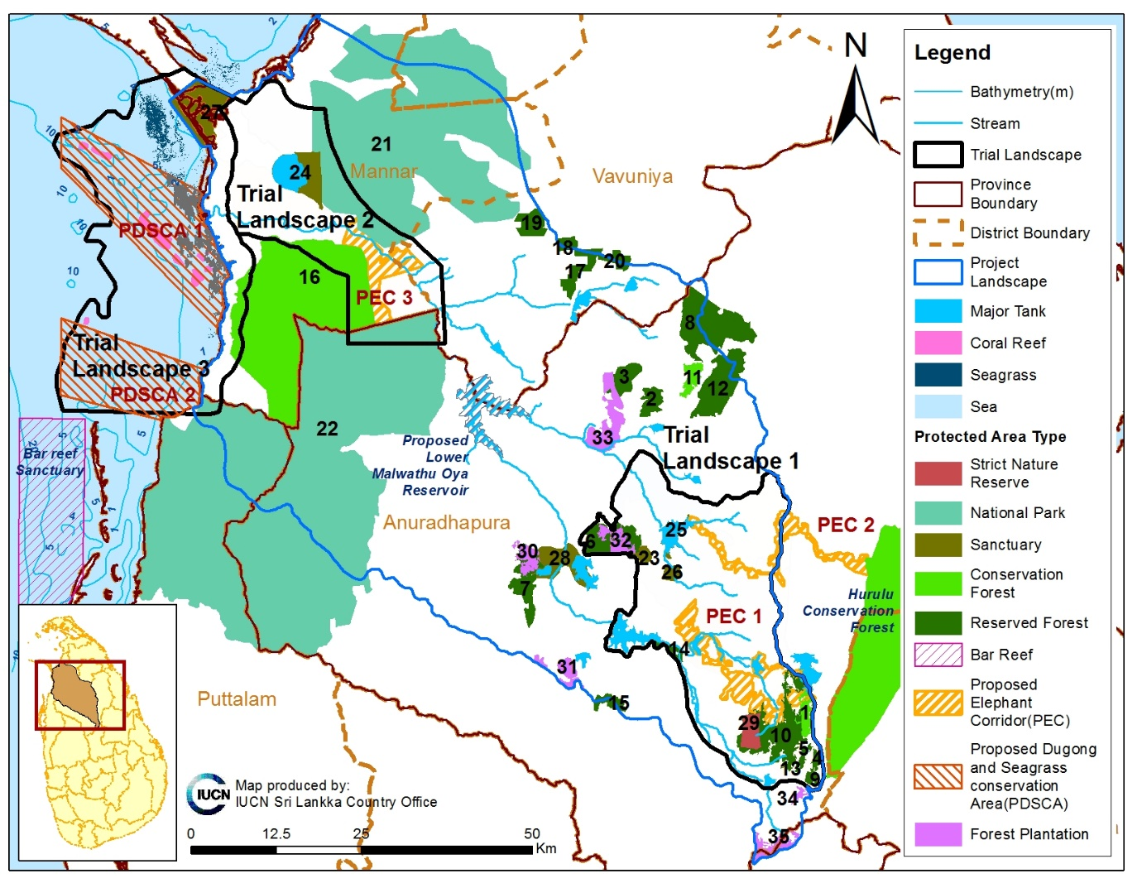
Figure 1. Forest plantations (given in pink) within the project landscape provided with numbers that refer to Table 1 for details. Only those protected areas outside the Trial Landscape and the proposed lower Malwathu Oya reservoir are labelled

Table 1. Extent of Teak forest plantations within the “Managing Together” project landscape (Source: data from FD)
No | Name of the Forest Plantation (FP) | Extent (ha)
30 | Anuradhapura FP | 1 030
31 | Batueathth FP | 1 071
32 | Mihintale FP | 1 219
33 | Poonewa FP | 2 931
34 | Tumbikulama FP | 317
35 | Murungahitikanda FP | 1 261
Total |  | 7 829

Established and managed forest plantations are only found around the Trial Landscape 1 within the entire Project Landscape. All above forest plantations are under the preview of the Forest Department of Sri Lanka, which is responsible for their silvicultural management. The main roles of Forest Department in relation to these production forests are described below based on excerpts from their website.

Nursery Management (excerpt from http://www.forestdept.gov.lk/)
A large number of seedlings are necessary for each forestry division per planting season to undertake forestation activities in the ranges which includes reforestation of second rotation areas, afforestation, forest restorative activities, social and community forestry programs, plant sales to the public etc. This operation needs highly skilled labor in order to get a good output together with highly technical management practices.

Silviculture Management Practices (excerpt from http://www.forestdept.gov.lk/)
Silvicultural practices are executed according to the Silviculture Manual. Selection of suitable sites, species play a vital role in addition to the production targets such as industrial timber, fuel wood, pulp wood etc. Future demand on different timber tree species has to be forecasted correctly. All the details are documented in a plantation journal prepared for each block.
Planting is normally carried out by the unskilled casual labor under the supervision of forest officers. Stacking and pitting should be done few days prior to the planting by following standard spacing specific to the species. Planting should be done when the topsoil is fully saturated. After planting, different scientific management practices have to be carried out such as, tending, weed control, clearing, singling and thinning. Branch pruning is also important to improve the bole quality of the timber log.

Forest Harvesting (excerpt from http://www.forestdept.gov.lk/)
Forest Plantations are harvested annually based on the allocations received to the Forest Department for the second or next rotation. Selected lands are handed over to the State Timber Cooperation (STC) for felling operations which are carried out through contractors who are selected through a procurement procedure. All the forestry operations are executed according to the accepted silvicultural guide lines and operations are closely monitored.

Forest Inventory (excerpt from http://www.forestdept.gov.lk/)
Forest inventory is playing the key role in plantation forestry in order to predicting the timber volumes and other important parameters which are important for planning and management. With the emerging trend of Carbon stocks forest inventory has integrated to the natural forests also. Forest Department is currently performing a National Forest Inventory (NFI) program including all the forests which are managed by both the Forest Department and Department of Wild Life Conservation.

Restoration (excerpt from http://www.forestdept.gov.lk/)
Population density of Sri Lanka shows significantly higher value with compared to the other developing nations. As a result, land for demand has emerged as a principal issue which leads to public unrest. Not only the public but also the investors indicate their hunger on lands. Almost all productive lands are populated and a conflict between the development and forests has aroused over the last decade.
As a result, most of the forest edges are degraded due to the periodic encroachments for agriculture, residence and acquisition of forest lands for infrastructure development.
Restoration of those degraded ecosystems is a challenge and Forest Department has launched many attempts to mitigate with the help of government, private sector, general public, and non government organizations.

Farmers Woodlot Management (excerpt from http://www.forestdept.gov.lk/)
This tool was very effective in order to re arrange a forest cover over the marginal agricultural lands. Majority of the land used was old chena lands. The predominant tree species planted in the dry and intermediate zones was Teak while in the wet zone Eucalypts.

Private Sector Forestry engagement (excerpt from http://www.forestdept.gov.lk/)
Most of the entrepreneurs are willing to invest their Cooperate Social Responsibility (CSR) funds for reforestation or restoration programs with the partnership of Forest Department. Forest Department is also having a plan to find the investors to re green the degraded forest areas which do not have sufficient funds from the government of Sri Lanka.
This common objective of two entities has driven to many success stories recently. Investors are encouraged to join hands with the Forest Department, not only for replanting but also to support the publications, infrastructure, eco-tourism activities and many other ways.

II. POTENTIAL FORESTRY INTERVENTIONS
Reforestation, afforestation and forest habitat enrichment in project landscape
The following sections adapted here from the Wildlife Management Plan of the Upper Elahera Canal Project can be used where relevant and further improved as this plan deals with the same landscape (IUCN and MMD&E (2017)]
In order to improve the overall habitat availability for wildlife, habitats with the potential to be enriched through assisted regeneration should be identified based on a GIS with land use and existing protected areas. Site selection for potential habitat restoration or enrichment will be based on field observations. Field data will then be fed in to the GIS database to develop a map depicting the spatial arrangement of proposed activities for each Trial Landscapes. Sites identified for restoration and the types of interventions proposed are summarised in Table A. Possible forestry related interventions within the Trial Landscapes are elaborated later.
Table A Summary of restoration interventions that could be proposed
Sites selected for vegetative restoration | Proposed types of vegetative intervention
Unpaved and earthen constructed canal banks | Restore and strengthen riverine forests with appropriate species. Mostly gap filling. (See intervention 1 below.)
Natural stream banks | Restore and strengthen riverine forests with appropriate species. Mostly gap filling. (See intervention 2 below.)
100m vegetation belt of Gasgommana (tree belt) in large tanks. | Restore the tree cover of peripheral lands with appropriate species. Mostly gap filling. Native species for natural areas and perennial woody crops for settlement areas. (See intervention 3 below.)  Potential tanks include, Manankattiya, Eru Wewa and Mahakanadarawa. Gasgommana includes natural areas and settlement areas.  This could also be co-financed for Upper Elahera Canal Project
50m vegetation belt of gasgommana (tree belt) in small tanks | There are number of small tanks. Gasgommana may include natural areas and settlement areas. (See intervention 3 below.)
Kattakaduwa of small and large tanks | Restore and strengthen kattakaduwa forests with appropriate species. Mostly gap filling. (See intervention 4 below.)

Intervention 1: Unpaved and Earthen Constructed Canal Banks —- Restore and Strengthen Riverine Forests with Appropriate Species
This includes mostly gap-filling of riverine forests found where there are previously constructed canals. These canals will be used heavily in the future with added flow.
The suggested species for riverine areas include are shown in Table B.

Table B. A selection of plants suitable for the tree strip along the canal stretch that is dug out with no cement surface.
Family | Scientific name | English name | Sinhala name | Tamil name
Combretaceae | Terminalia arjuna | Arjun Tree | Kumbuk | Marudu
Flacourtiaceae | Hydnocarpus venenata | Marothi tree | Makulu | Makul /Maravetti
Ebenaceae | Diospyros malabarica | Indian persimmon | Thimbiri | Panichchai
Rutaceae | Chloroxyclon swietania | Satinwood | Burutha | Muruthai
Euphorbiaceae | Drypetes sepiaria | No name known | Weera | Weerai
Anacardiaceae | Mangifera zeylanica | No name known | Etamba | Kaddu-ma
Lecythidaceae | Barringtonia racemosa | No name known | Diya midella | No name known
Pandanaceae | Pandanus kaida | No name known | Vetakeiyya | No name known
Arecaceae | Caryota urens | Fish tail palm | Kitul | Kitul tippilipana
Myrtaceae | Syzygium cumini | Java plum | Dan | Naval / Perunaval
Fabaceae | Millettia pinnata | Pongam | Karanda | Punku/Poona
Sapotaceae | Madhuca longifolia | Honey tree | Mee | Illupai / Kuligam

Intervention 2: Natural Stream Banks — Restore and Strengthen Riverine Forests with Appropriate Species
This is mostly gap-filling work. The network of streams form the linkages of tanks and in the future these will be used heavily with an added flow. The suggested species for riverine forest development include the same species mentioned under intervention 1 (above).

2.1 Restoration of Vegetation Cover around Tanks
Restoration of vegetation cover of tanks recognises the benefits of green areas for indigenous biodiversity, soil conservation and hydrological performance; while enabling productive social use of the cascade landscape.
A whole range of cascade services can be affected when ecosystems become degraded — such as the decline of water quality and quantity; siltation of tanks; loss of biodiversity and loss of soil fertility. The proposed vegetative restoration operation is in line with the ecosystem approach in landscape restoration concepts, usually applied where forest or agro-forests are depleted, and the quality of ecosystem services are affected. It does not aim to re-establish historical vegetation of the cascade, but rather, it aims to strengthen the resilience of selected land plots associated with tank ecosystems.
It also aims to support village communities as they strive to increase and sustain the benefits they derive from the management of their private lands. This tree planting dominated initiative should improve soil conservation, hydrological performance, ecological functioning of the cascade landscape and the well-being of the human communities that reside within the cascade landscape. It is important that restoration should be a collaborative process, involving a wide range of stakeholders and with flexibilities to accommodate ground realities, as the work goes on.
Village tanks comprise several elements. The main components of a village tank are described below.
Each village tank has several components, each of which fulfils an ecological function and provides an ecosystem service to the communities which live near the tank. Two such main components are
- The gasgommana (windbreak of trees): an area planted with large trees of the same species that act as a windbreak to minimise evaporation from the surface of the tank;
- The kattakaduwa (interceptor): the stretch between the tank bund and paddy fields consisting of three land phases (water hole, marshy land and dry upland). This acts as a downstream wind barrier, reduces tank seepage, prevents sodium, magnesium and iron from entering the paddy land and safeguards the tank bund
Intervention 3: Restoration of 100 M Vegetation Belt of Gasgommana (Windbreak of Trees) In Large Tanks
Restore the tree cover of peripheral lands with appropriate species. This mostly includes gap-filling with native species for natural areas and perennial woody crops for settlement areas.
The areas for such restoration include Hurulu Wewa, Manankattiya Wewa, Eru Wewa Mahakanadarawa Wewa. Planting needs to be carried out both in natural areas and settlement areas.
Table 30 presents a selection of suitable plants for the restoration of the gasgommana (except in settlement areas).
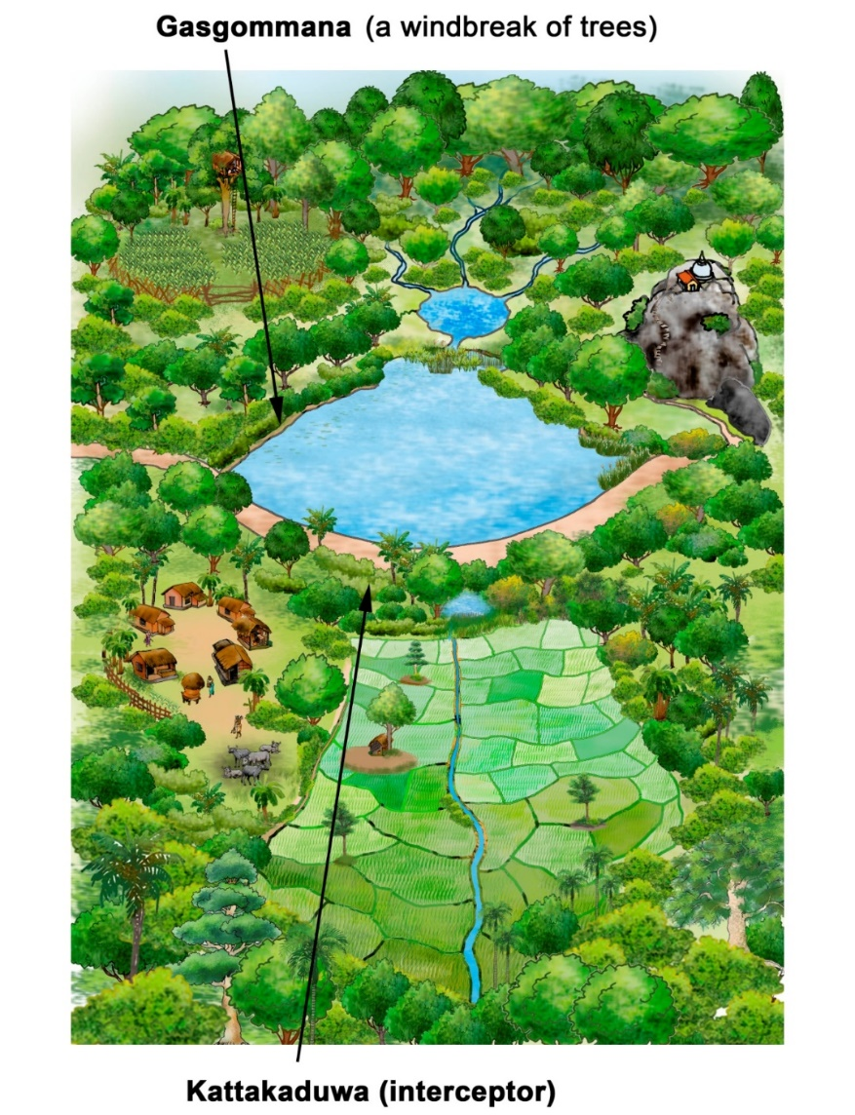
Figure X. Diagram showing selected elements of a tank (Source: IUCN, 2016)

Table C. A selection of suitable plants for the restoration of the gasgommana (except in settlement areas)
Family | Scientific name | English name | Sinhala name | Tamil name
Meliaceae | Azadirachta indica | Margosa/Neem | Kohomba | Vembu
Fabaceae | Bauhinia racemosa | No name known | Maila | Atti
Tiliaceae | Berrya cordifolia | Trincomalee wood | Halmilla | Chavandalali
Fabaceae | Cassia fistula | Indian laburnum | Ehela | Thirukondrai
Rutaceae | Chloroxyclon swietania | Satinwood | Burutha | Muruthai
Euphorbiaceae | Drypetes sepiaria | No name known | Weera | Weerai
Moraceae | Ficus benghalensis | Banyan | Nuga | Ari
Rutaceae | Limonia acidissima | Wood apple | Divul | Vellai maram
Anacardiaceae | Mangifera indica (select semi-wild varieties) | Mango | Wal Amba | Mangai
Sapotaceae | Manilkara hexandra | No name known | Palu | Palai
Rubiaceae | Morinda coreia | Indian Mulberry | Ahu | Manchavanna
Sterculiaceae | Pterospermum suberifolium | No name known | Welang | Tadu
Myrtaceae | Syzygium cumini | Java plum | Dan | Naval / Perunaval
Fabaceae | Tamarindus indica | Tamarind | Siyambala | Pulli
Verbenaceae | Vitex altisima |  | Milla

Intervention 4: Restoring and Strengthening the Kattakaduwa of Small and Large Tanks
Restore and strengthen kattakaduwa forests with the species listed in the table below. This involves mainly gap-filling and the effective areas for intervention will vary depending on the specific circumstances.
Table 32 is a working list of plants suitable for locations where soil is moist most of the months (for example the kattakaduwa and tank edge habitats).
Table D. A selection of suitable plants for the restoration of tanks, for the kattakaduwa and tank edge habitats
Family | Scientific name | English name | Sinhala name | Tamil name
Sapotaceae | Madhuca longifolia | Honey tree | Mee | Illupai / Kuligam
Fabaceae | Millettia pinnata | Pongam | Karanda | Poona / Punka / Punku
Myrtaceae | Syzygium cumini | Java plum | Dan | Naval / Perunaval
Combretaceae | Terminalia arjuna | Arjun | Kumbuk | Maruti
Combretaceae | Terminalia catappa | Country almond | Kottamba | Amandi-maram
Verbenaceae | Vitex leucoxylon | No name known | Nabada. | Nirnochi

4.1 Restoring vegetation associated with settlement areas (home gardens and abandoned chena)
The associated home gardens in the landscape of the cascade can play a vital role in safeguarding the tank ecosystem, if they have a good canopy cover and silt traps. In this regard, it is highly recommended that such home gardens have closely planted live fences and canopy cover provided by perennial crops that support livelihoods. Live fences make a good ‘filter’ with plants growing at 20 cm gap.
Live fences can be erected using sticks of Mexican lilac (Gliricidia) and Drumstick trees (Moringa oleifera), both of which support community needs. In addition to Gliricidia and Drumstick trees, people like to have Justicia adhatoda (Pavatta/Adathoda) also and there may be other species selected by communities.
- When planting stems/cuttings, cut a stem from the mature breaches of a tree, approximately 5 cm diameter.
- Then put a mark to show the top side of the stick.
- Without delay, plant the cuttings with the top mark showing and cover the top of the stick with a poly-bag to minimise drying. Ideally sticks can be inter-mixed and planted at 20-30 cm gaps to better trap silt. A hole, 20-30 cm deep, with just enough diameter to insert the stick upright, is adequate.
- Live fences need to be erected against the slope direction to ensure the control of soil erosion and increase ground water recharge.
- Consult local knowledge in erecting live fences. However, the choice of plants and planting gaps need to be decided jointly with the community to accommodate their views as a participatory exercise.
Improvement of the perennial crop cover of home gardens can make a significant positive impact to the tank ecosystem if it mimics a natural catchment area.
Various perennial crops can be planted in consultation with each individual house holder and recommendations of local agricultural. The following choice of 15 crop plants are suggested as a general guide. Field planting can be done more or less similar manner explained earlier. However, the community is well aware of planting practices.
Table E. A selection of suitable plants for the restoration of home gardens
Family | Scientific name | English name | Sinhala name | Tamil name
Arecaceae | Cocos nucifera | Coconut | Pol | Thengai
Anacardiaceae | Anacardium occidentale | Cashew nut | Cadju | Munthirikai / Munthiripalam
Rutaceae | Aegle marmelos | No name known | Beli | Vilvam
Moringaceae | Moringa oleifera | Drumstick | Murunga | Murungakkai
Fabaceae | Sesbania grandifora | No name known | Kathurumurunga | Ahatti
Rutaceae | Limonia acidissima | Wood apple | Divul | Vellai maram
Moraceae | Artocarpus heterophyllus | Jak | Kos/Herali | Palapalam
Anacardiaceae | Mangifera indica | Mango | Amba | Mangai
Citraceae | Citrus spp. | Citrus fruits (different varieties)
Lythraceae | Punica granatum | Pomegranate | Delun | Mathulam palam
Oxalidaceae | Averrhoa carambola | Star fruit | Kamaranga | Tamanta
Myrtaceae | Psidium guajava | Guava | Pera | Koiya
Musaceae | Musa paradisiaca | Banana | Kesel | Valai
Annonaceae | Annona squamosa | Custard apple | Anoda | Annamunna
Anacardiaceae | Spondias dulcis | Hog plum | Ambarella | Ampallai

Table F. A selection of plants for shrub covers in forest and abandoned chena areas
Family | Scientific name | English name | Sinhala name | Tamil name
Rhamnaceae | Ziziphus mauritiana | Indian jujube | Masan | Ilantai / Illantai
Rhamnaceae | Ziziphus rugosa | No name known | Maha Eraminiya | Churai
Aristolochiaceae | Aristolochia indica | Indian birthwort | Sassanda | Isuru
Rutaceae | Toddalia asiatica | Forest pepper | Kudumirissa | Kandai
Rutaceae | Atalantia ceylanica | No name known | Yakinaran | Pey-kuruntu
Rutaceae | Atalantia rotundifolia | No name known | Yaki-Naran | No name known
Rutaceae | Limonia acidissima | Wood apple | Divul | Villai maram
Rutaceae | Glycosmis angustifolia | No name known | Bolpana | No name known
Rutaceae | Glycosmis mauritiana | No name known | Orangeberry | No name known
Annonaceae | Polyalthia korinti | No name known | Ulkenda | No name known
Capparaceae | Capparis zeylanica | Ceylon caper | Sudu-Welangiriya | Kattoddi / Vennachchi
Fabaceae | Senna auriculata | Matara tea/Tanner’s Cassia | Ranawara | Avarai
Apocynaceae | Carissa spinarum | No name known | Heen-Karamba | Chiru-kila
Rubiaceae | Ixora coccinea | Jungle flame | Rathmal | Vedichi
Fabaceae | Derris scandens | Forest beanstalk | Kalawel | Kalungu kodi
Sapindaceae | Allophylus cobbe | No name known | Kobbe | Amarai
Arecaceae | Calamus rotang | Common rattan | Weval | Pirambu
Hippocrateaceae | Salacia reticulata | No name known | Himbutu | No name known
Arecaceae | Phoenix pusilla | Wild date | Wal indi | Inchu
Cycadaceae | Cycas nathorstii | Fern Palm | Madu | Eentha Panai

Table G. A selection of plants suitable for the shrub cover in abandoned tracts or edges of paddy
Family | Scientific name | English name | Sinhala name | Tamil name
Rubiaceae | Ixora coccinea | Jungle flame | Rathmal | Vedichi
Fabaceae | Derris scandens | Forest beanstalk | Kalawel | Kalungu kodi
Arecaceae | Calamus rotang | Common rattan | Weval | Pirambu
Acanthaceae | Justicia adhathoda | Malabar nut | Pavatta | Adathoda

Table H. A selection of plants suitable for the tree cover in abandoned tracts or edges of paddy
Family | Scientific name | English name | Sinhala name | Tamil name
Myrtaceae | Syzygium cumini | Java plum | Dan | Naval / Perunaval
Fabaceae | Millettia pinnata | Pongam | Karanda | Punku/Poona
Combretaceae | Terminalia arjuna | Arjun | Kumbuk | Marudu
Sapotaceae | Madhuca longifolia | Honey tree | Mee | Illupai / Kuligam

